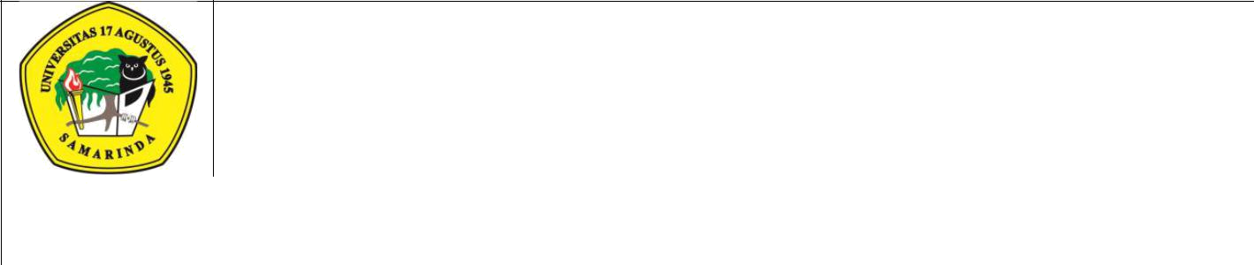
UNIVERSITAS 17 AGUSTUS 1945 SAMARINDA
Jl.Ir.H.Juanda No.80 SamarindaTelp. (0541)743390

Kalimantan Timur 75124, Indonesia http://untag-smd.ac.id/

 |  |  | PENDAFTARAN SEMINAR PROPOSAL
 |  |  |  |  | FM-PM-07.4/01.01/R0
 | Nama |  | :___________________________________________________
 | NPM |  | :___________________________________________________
 | Hari/Tanggal |  | :___________________________________________________
 | Alamat Sekarang |  | :___________________________________________________
 | Telepon |  | :___________________________________________________
 | Alamat Permanen |  | :___________________________________________________
 |  |  | ___________________________________________________
 |  |  | ___________________________________________________
 | Telepon |  | :___________________________________________________
 | Judul |  | :___________________________________________________
 |  |  | ___________________________________________________
 |  |  | ___________________________________________________
 |  |  | ___________________________________________________
 | Pembimbing I |  | :___________________________________________________
 | Pembimbing II |  | :___________________________________________________
 | Pembimbing 1 |  |  |  |  | Pembimbing II
 |  | Pemohon |  | Diperiksa Oleh: |  |  | Disetujui Oleh:

Nama:NPM:Kepala Bagian AkademikKetua Prodi Adm.NegaraTanggal:Tanggal:Tanggal:

