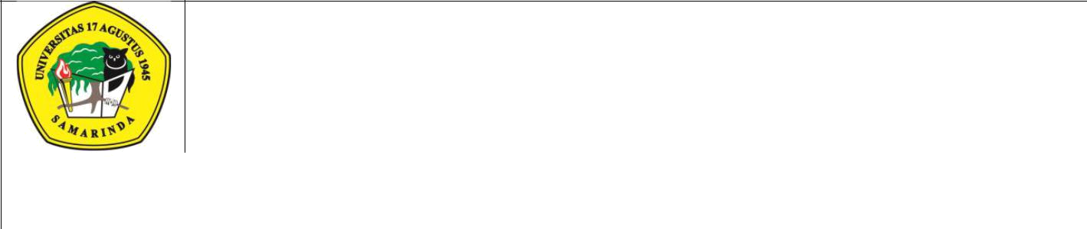
UNIVERSITAS 17 AGUSTUS 1945 SAMARINDA
Jl.Ir.H.Juanda No.80 SamarindaTelp. (0541)743390

Kalimantan Timur 75124, Indonesia http://untag-smd.ac.id/

 |  | BIMBINGAN TUGAS AKHIR
 |  | FM-PM-07.4/01.01/R0
 | Nama | :___________________________________________________________________
 | NPM | :___________________________________________________________________
 | Program Studi | :___________________________________________________________________
 | Judul | :___________________________________________________________________
 |  | ___________________________________________________________________
 |  | ___________________________________________________________________
TANGGAL |  | MATERI BIMBINGAN | PARAF
PEMBIMBING

